To make your own anatomical heart cream center chocolates, you will need:
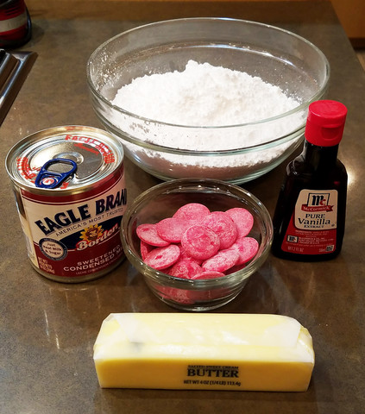
- 12 ounces of high quality *white chocolate or 1 bag of red candy melts and 2 tablespoons white candy melts
- *If using white chocolate, you will also need red powdered food coloring.
- 2 1/2 cups powdered sugar, divided
- ½ can (about ½ cup) sweetened condensed milk
- ½ cup butter, melted
- ½ Tablespoon flavoring of your choice (mint, vanilla, almond, etc.)
You will also need:
- Small, microwave safe bowl
- Larger mixing bowl
- Anatomical heart mold
- Red paper mini-muffin cups
- Parchment paper
- 4 chopsticks
- Spatula
- Food safe paint brush
- Coffin box (full directions down below…along with template. Just keep scrolling.)
In a double boiler, melt down your white chocolate or white candy melts (depending on what you’re using) until they’re melted into a smooth liquid. Make sure you’re stirring constantly.
Using your food safe paintbrush, give each of your heart mold cavities a thin swipe of chocolate, focusing on the center along where the veins and valves are. In a real heart, this would be fat as well as what is called the “silver skin.” (To see how a real heart looks with all this on, check out my recipe, Roasted Heart of my Enemies, here.)
Pop your molds into the fridge for about 5 minutes or until the white chocolate is set.
If using actual white chocolate in place of red candy melts, now is the time to add your powdered red food coloring to the remainder of your chocolate. Add in enough powdered food coloring to achieve a deep bright red and stir well to mix.
If using the red candy melts, melt them down by microwaving in a microwave safe bowl in 15-second bursts, stirring between each zap until your candy is smooth and liquid.
Allow to cool to just above room temperature. You want the red chocolate to be warm enough to pour smoothly, but not so warm that it melts the white chocolate you’ve already placed in your mold.
Pour your cooled but still liquid red chocolate into your heart-shaped mold, filling each cup all the way to the top. Let the candy sit for about 3 minutes, then carefully pour the excess back into your melting bowl.
Stack your chopsticks into a frame shape just slightly smaller than your heart mold over a piece of parchment paper. Invert your mold over this chopstick frame and allow the excess chocolate to drain out for approximately 10 minutes. Turn your mold right side up and use your spatula to scrape the excess chocolate off the top and sides of your mold. Pop the mold (still right side up) into your fridge for another additional 10 minutes to allow your chocolate to firm up.
While your hearts are firming up, combine 2 cups of your powdered sugar with the melted butter, your sweetened condensed milk and the flavoring of your choice (I used mint for this batch). The mixture should come together into an incredibly thick and sticky dough.
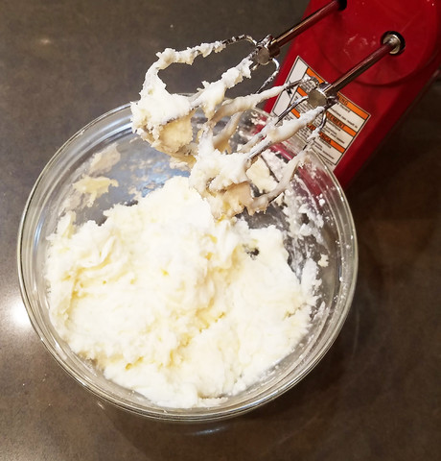
When it’s too thick to continue mixing, turn out onto a surface liberally dusted with more of your powdered sugar.
Knead the dough, adding more powdered sugar as needed, until you end up with a dough that is pliable and glossy.
Now is also the time to add in any food coloring you want. I opted for an equally deep red. Just knead this in to your dough as well. If using the powdered food coloring, just mix it right in and knead to combine. If using liquid food coloring, be aware you may need extra powdered sugar to help balance out the liquid you’re introducing to your dough. Again, you want the dough to be smooth and pliable, but not overly sticky.
Remove your chocolate hearts from the fridge.
Pinch off a small amount of your dough and press into your heart molds and fill them up, making sure you leave a small amount of space between the top of your dough and the top of the mold to accommodate for another layer of melted chocolate.
Pour the remainder of your melted red chocolate on top of your now filled heart molds and again use your spatula to smooth down the edges and flatten the back.
Return the mold to the fridge for an additional and final 15-minutes.
Unmold your chocolates onto a plate and admire how incredible they look. Ooh, shiny and gorgeous!
Set these aside and let’s focus on making that coffin shaped chocolate box!
For this you will need:
- Coffin template for lid and main box
- Glue stick or double stick tape
- Scissors
- Pen or pencil
- Ruler
- Computer
- Printer
- Red card stock
- Black card stock
- Black Washi tape
- Red Washi tape
- Items to decorate your final box
Start by first printing out the template from the file here.
The file is two 8 ½ x11” pages. Make sure when you print them that you have your printer set portrait and “scale to fit media.”
Because I wanted to make my box extra fancy and use heavy, colored cardstock, I printed my two pages out on plain white printer paper and then glued them to two equally sized pieces of light cardboard, creating a template. I then cut around the template pieces and transferred those shapes to my colored paper.
I wanted to make the outside of my coffin black and the inside red, so I traced each template twice, once on black and once on red. I also traced an additional lid onto some courregated black specialty paper I picked up at the craft store to give my box some additional design texture on the outside.
The paper I used was textured, so I made sure to trace my templates onto the back of my sheets, lining them up with the direction I wanted my texture to go on the front.
You should end up with a minimum of four pieces total, two for the lid (one red and one black) and two for the main box (again, one red and one black). I ended up with five, as I also cut out an additional piece for my lid using the courregated black cardboard.
Start by folding your two primary box pieces along the dotted lines, bringing your flaps in towards the center of your box. I found that using the straight edge of a ruler helped me make sure my fold lines were crisp and sharp.
For the outside of your primary box, fold your flaps upward with the right side facing down. For the interior, do the reverse, making sure the right side of your paper is facing upward. This way when the two pieces are put together, the outside of your box will have the right side of your bottom paper facing outward and the inside will have the right side of the paper facing outward as well.
Place a generous amount of glue on the inside section of your outside piece and glue your inside piece on top, sandwiching the glue between the two pieces. Allow this to dry.
Do the exact same thing with your coffin lid, again making sure that your inside piece is right side up and your outside piece is wrong side up when folding and gluing.
Once those two pieces are dry, it’s time to start gluing and assembling the flaps.
I found it was easier to work in a circular motion, fist completing the inside flaps and then tackling the outside flaps as I glued.
Starting with your bottom coffin piece, first fold up your bottom inside flap and glue your tab to the outside of the flap next to it, making sure that the tab is on the outside of your inside piece (I know, it sounds way more complicated than it is, but the goal is to make sure that when you look into the box, all you see are the lines where the corners meet, not the tabs holding it all together.)
Repeat this with your outside flaps, not only hiding the tabs on the “inside” but also securing them to the outside of your inside flaps using glue (again, confusing, right? Once you start gluing it all together, it’ll make more sense…trust me.)
Repeat these steps with the lid.
At this point you can stop if you’d like. You should have a complete box that includes a base (bottom) and a lid. The outside should be black and the inside should be red.
To clean up the edges, I ran a strip of black Washi tape around the top edge of both my lid and main box, folding it over to cover both the outside and inside with an equal strip of black. I then ran a second red piece of Washi tape around the inside edge of the main box. This isn’t needed, but it cleans up the edges and makes them pretty.
The, because I’m fancy and shit, I cut all the tabs off my black courregated piece and glued that to my lid. I also glued an additional strip of vertical courregated cardboard around the outside edge of my main box piece, but again, this is purely optional.
Finally, decorate the outside of your box any way your dark little heart desires. I picked up a few red bows from the craft store post-Christmas and found they were perfect for this project. I also added a single giant spider because, well…why not?
Line your box with a piece of black tissue paper. Now it’s time to add our chocolates! Gently place each heart into a paper mini-muffin cup and transfer to your now decorated chocolate box.
While this recipe only covers how to make the mint chocolate anatomical hearts, I also supplemented my gift box with a few white chocolate versions of my Scary Fast Raspberry Truffles and a few store-bought pieces I had from another box I purchased earlier in this week (I’m calling those research…)
Close up your box and give to your intended…or better yet, just keep for yourself and enjoy!

